

|  |  |  |  |  |  |
| --- | --- | --- | --- | --- | --- |
| Programme | : | **BTech. CSE Core** | Semester | : | **Win 2021-22** |
| Course | : | **Operating Systems** | Code | : | **CSE2005** |
| Faculty | : | **Dr. Shyamala L** | Slot | : | **L25+L26** |
| Name | : | **Hariket Sukesh Kumar Sheth** | Register No. | : | **20BCE1975** |

**Lab 2:**Boot Loader – to load a particular OS. OS Image – code to access from BIOS to loading the OS

**1**

|  |  |  |  |
| --- | --- | --- | --- |
| Date: 28-01-2022 | LAB 02 | Bootloader – Loading OS |  |

**LAB 2**

**Aim:** To write a boot loader – to load a particular OS. OS image – code to access from BIOS to loading the OS.

**Steps:**

**Step 1:** Installation of NASM and QEMU

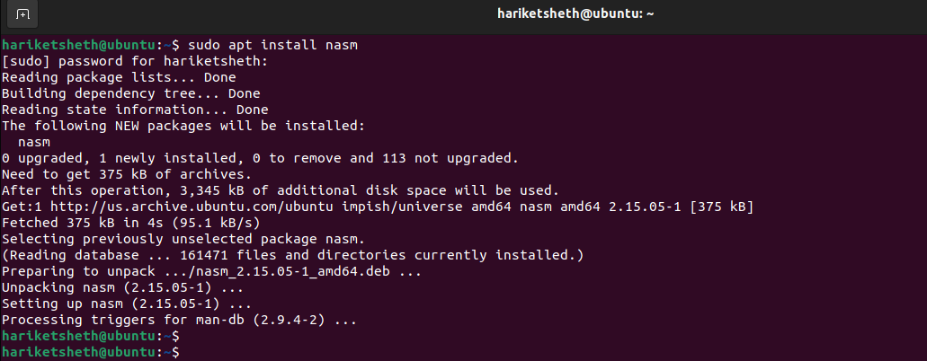

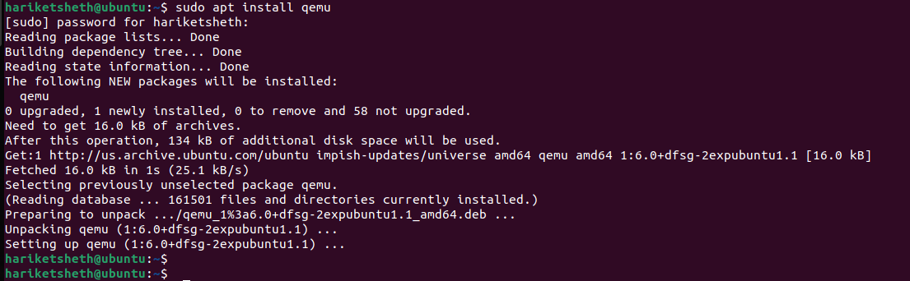

**2**

**Step 2:** Create bootloader1.asm and compile after writing the code. Run the same using emulator

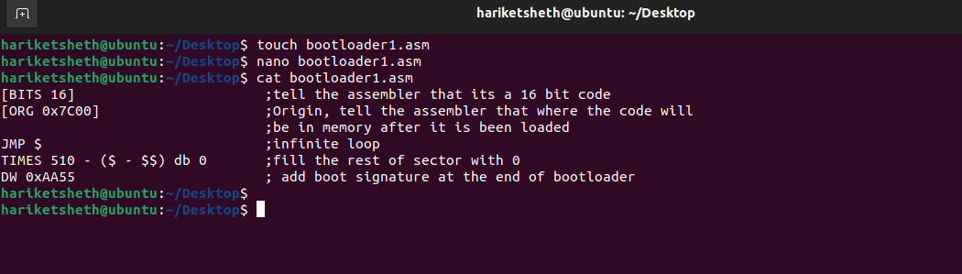  
 **nasm bootloader1.asm -f bin -o boot.bin  
qemu-system-x86_64 -drive file=boot.bin,index=0,media=disk,format=raw**

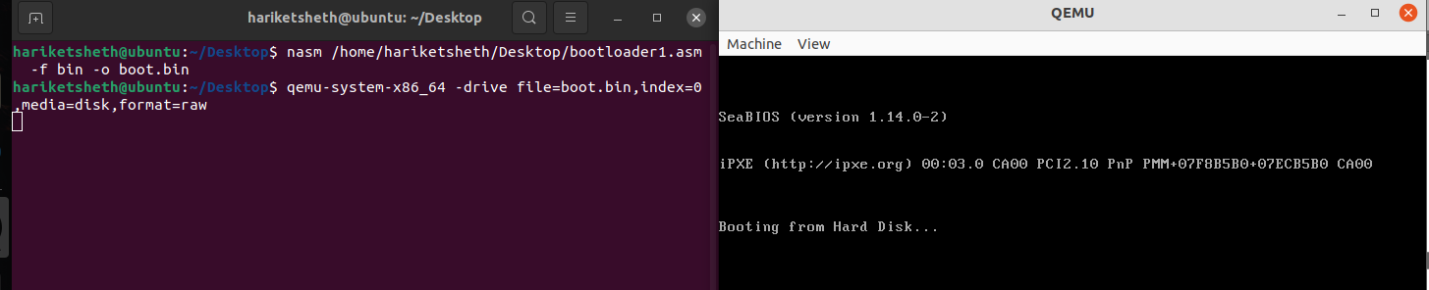**Output:**

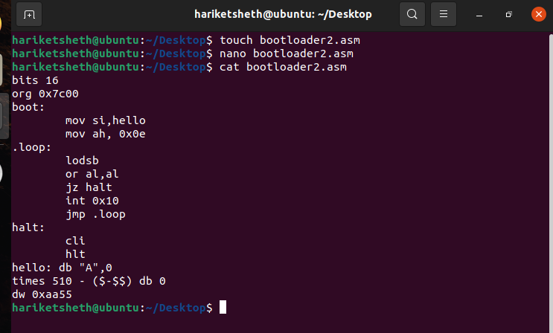**Step 3:** Create 2nd Bootloader that prints ‘A’ on the screen

**3**

**nasm bootloader2.asm -f bin -o boot2.bin  
qemu-system-x86_64 -drive file=boot2.bin,index=0,media=disk,format=raw**

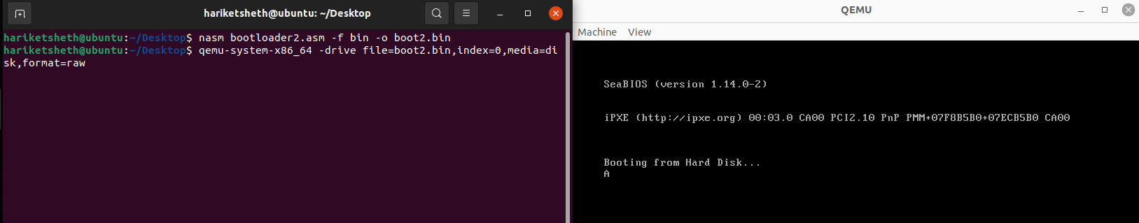

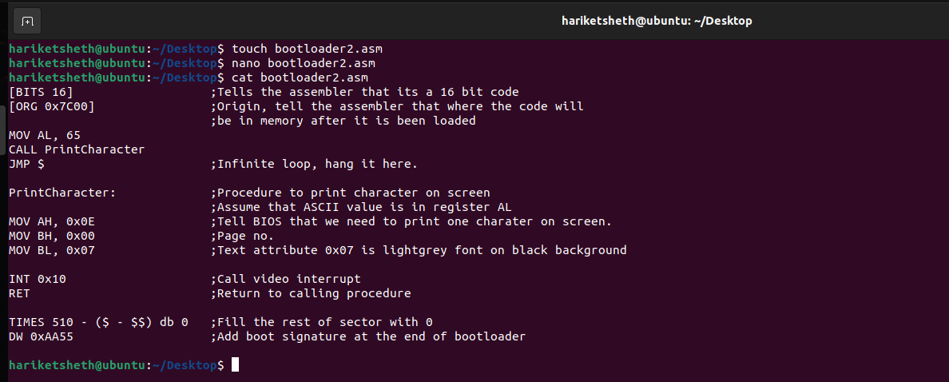**ANOTHER WAY OF BOOTLOADER**

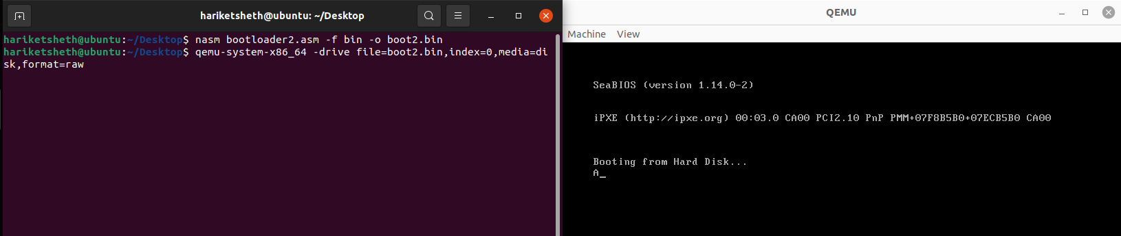

**4**

**Step 4:** Create 3rd Bootloader that prints name “Hariket”

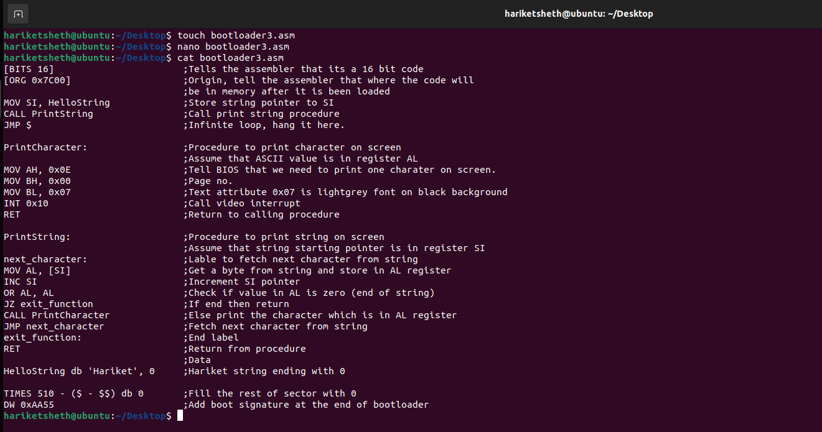

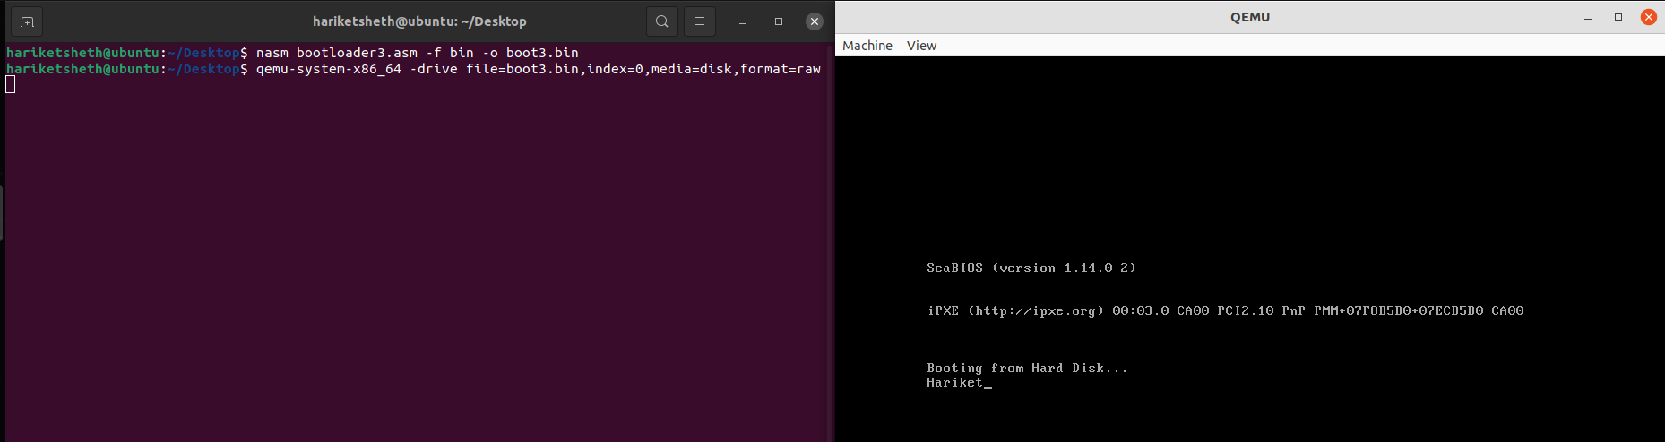

**5**

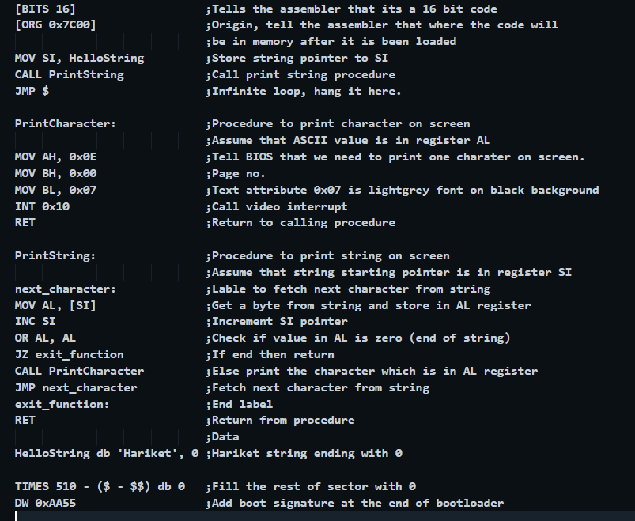

**6**